445 S. Gay St., Suite 301
Knoxville, TN 37902
(865) 637-7901
(865) 632-2489
Fax (865) 637-3781

EA MEMBER COMMUNICATION – DECEMBER 2023

Welcome our new Labor Relations Specialist, Cody Workman

Cody Workman joined the Engineering Association in October 2023 as a full time Labor Relations Specialist. Cody is a U.S. Navy veteran that served our country as a military police officer. After he completed his service, he completed his Bachelor of Science in Exercise Physiology and is now wrapping up his Master of Business Administration with an emphasis in Human Resources. He has held numerous leadership positions that have enabled his passion for serving those he has worked with. In the past few years, he has held positions as an Executive Director of an Assisted Living facility and a Regional Human Resources Director focusing on enhancing the employee experience throughout the southeast.
We are excited to welcome Cody to the team as we begin preparing for negotiations for the Fiscal Year 2025. We believe his dedication and expertise will assist the Engineering Association in providing the best service to those represented by our Union. Outside of work, Cody enjoys spending time with his wife, one year old son, and Australian Shepherd exploring the outdoors and tasty food in Chattanooga, TN.

EA Wins Arbitration

Your Union was victorious in winning an arbitration for EA/IFPTE Local 1937-member Timothy Hubbard in getting his job back. This was a 5-year collaborative effort between the EA and the IFPTE. Please look further on the EA website for President Carolyn Wilson’s response. This favorable decision is also posted on the IFPTE website and a topic on the national AFL-CIO Daily Brief.
Read Hubbard’s Full Letter Here

Upcoming Negotiations

Upcoming EA negotiation planning for FY25 will be ongoing through April 2024. Contract negotiations with TVA are currently scheduled for May 2024. The EA has listened to feedback from our sections, DURs, and our membership participation and comments through the PIERS quarterly meetings to ensure your concerns are addressed.

PIERS Alliance Update

The PIERS Alliance continues living out its core values through Professionalism, Integrity, Excellence, Relationships, and Service. We believe highlighting these values will result in more inclusion in the workplace, stronger collaboration between the EA and TVA management, and improved relationships among TVA team members and management. These focal points will allow us to set higher standards and achieve better solutions. PIERS main goal is to open lines of communication between EA members and members of management to help identify issues and work toward solving them at the lowest level. PIERS has had success in leading section/area meetings that have created a great space to open the floor to provide answers to any questions that have been presented. Please click here to see a current list of our Q&A. If anyone has any concerns, feedback, and/or ideas, please reach out to a Champion or email the piersalliance@tva.gov mailbox.

UPCOMING PIERS MEETINGS

.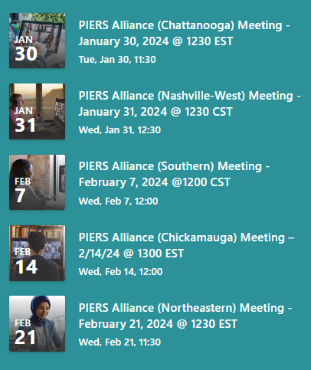.

Workstream 6

With existing and future valley wide growth and subsequent increased energy demands, TVA will be expanding our current generation assets. Workstream 6 (WS6) is a TVA initiative to identify engineering and technical asset availability to meet upcoming demands. The data collected will be entered into TVA’s labor forecast center which will track supply/demand valley wide in real time. The EA has participated in this WS6 initiative from the beginning and looks forward to supporting the additional demand for represented engineering and technical personnel.

Quality PCS Initiative

The EA is participating in TVA’s ongoing efforts with onboarding project control specialists (PCS). A gap was identified with how TVA onboards and trains PSC personnel and has leveraged the EA to assist with closing this gap. The EA is working with TVA to develop recruitment and training strategies that will benefit our current PCS members and new PCS members needed to ensure we have a pipeline ready to staff new projects that will ensure generation assets will meet our customers’ current and future energy demands.

Exams, Certifications, and Licenses-Tuition Reimbursements

TVA provides reimbursement for exams, licenses and certifications that are required to perform needed business functions. In some instances, TVA may also provide tuition reimbursement to further your education. See the Benefits SharePoint or contact your HR partner for addition al information.

Additional Topics

The EA is continually monitoring TVA’s Cyber-Security Phishing program. This is an ongoing action that we have in place to address any disciplinary actions taken that affects you, our members. We welcome feedback from you and will address any business unit specific issues that arise.

In Solidarity,

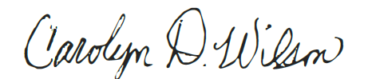

Carolyn Wilson – EA Valley Wide President

